Create an Activity Policy that will detect a suspicious activity such as mass downloading of files in a short timeframe.
Step 1 | 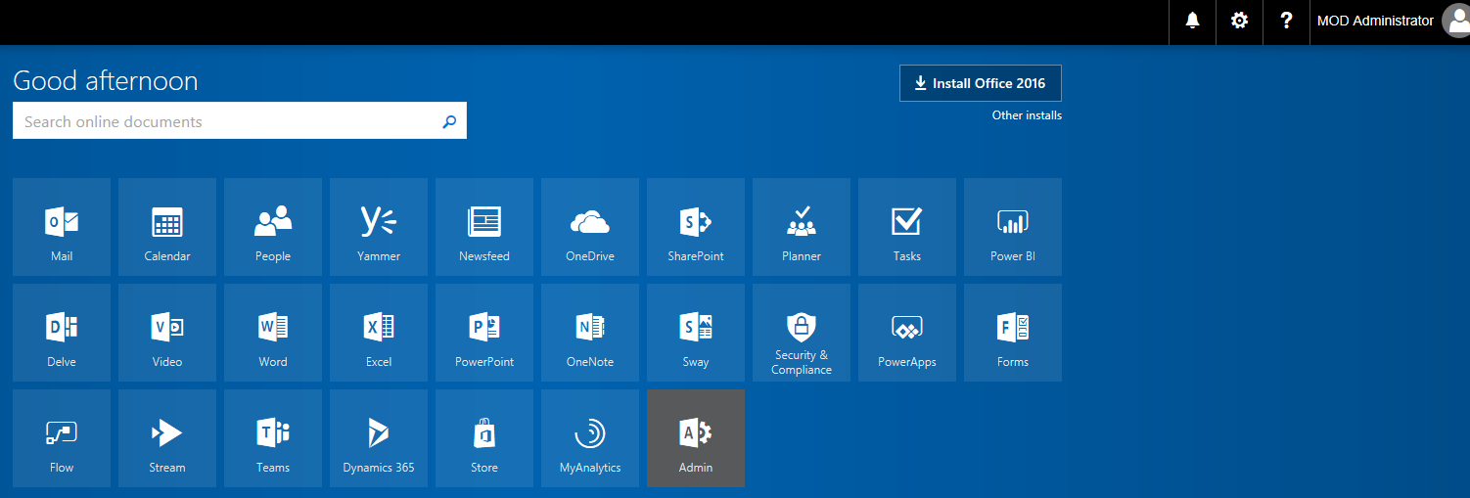 | Log into you tenant  https://login.microsoftonline.com/  and the click on the Admin Center 'App'
Step 2 | 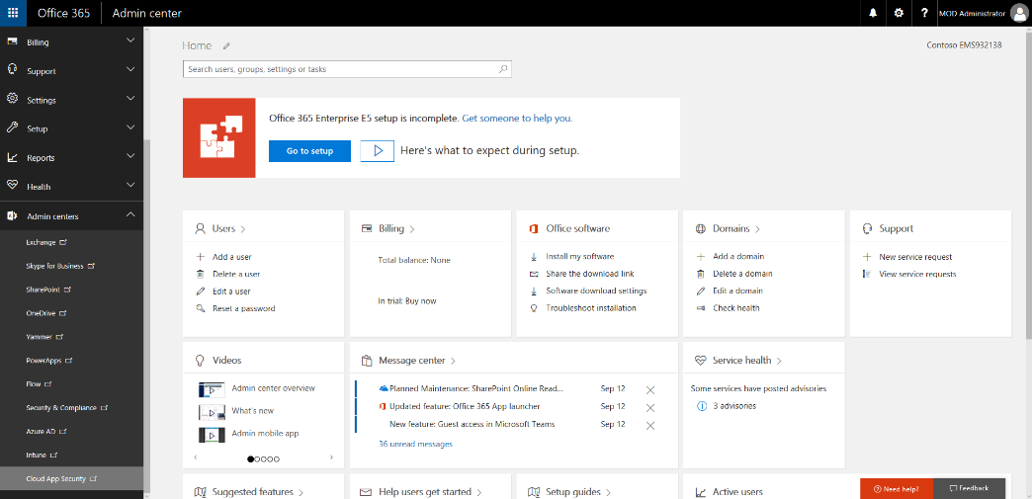 | In the left navigation, click on Admin Centers then click on Cloud App Security
Step 3 | 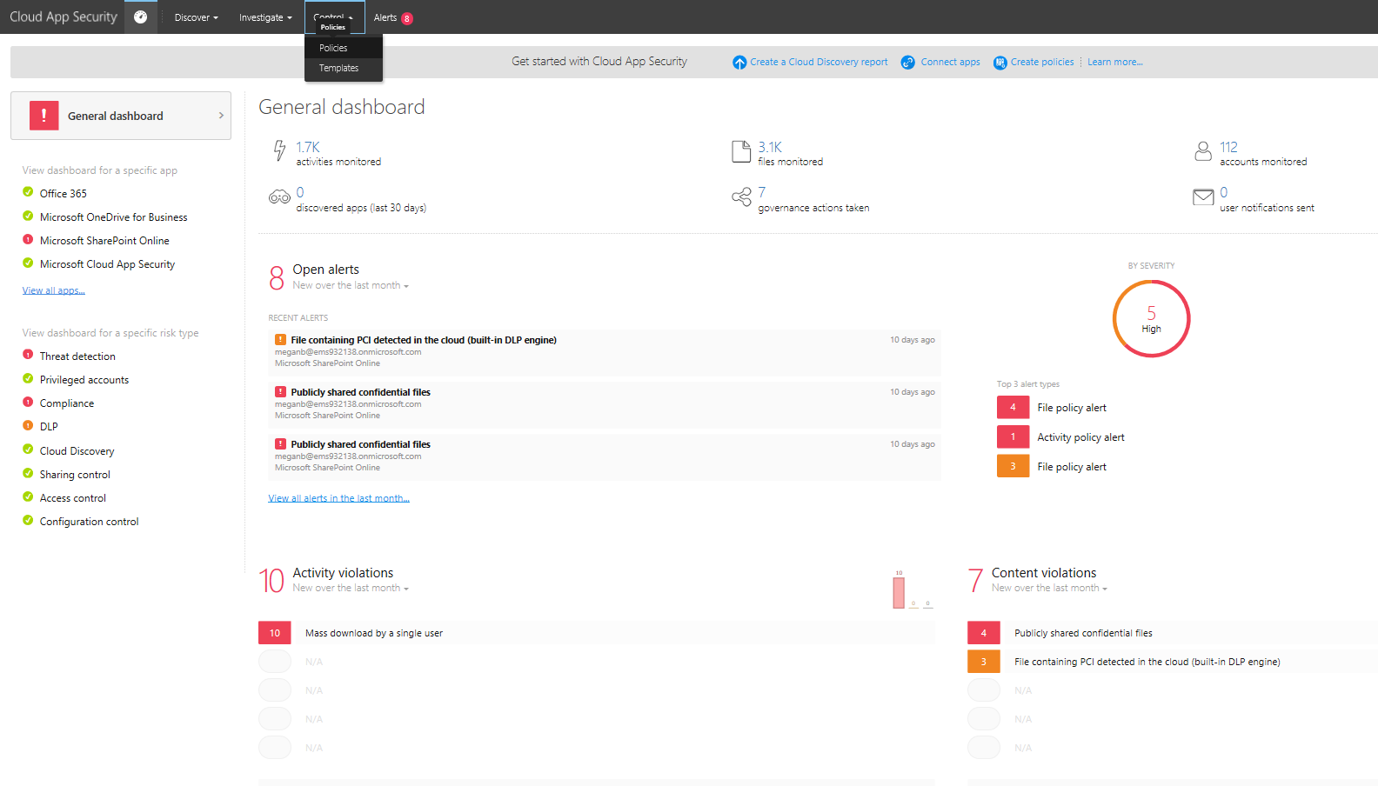 | From the Cloud App Security Home Page, From the Control menu, select Policies
Step 4 |  | CLICK STEP(S)  Click Create policy.
Step 5 |  | CLICK STEP(S)  Click Activity policy.
Step 6 |  | First, let’s select a policy template from the Policy template drop down menu.  CLICK STEP(S)  Click Policy template drop down menu.
Step 7 |  | As you can see there are a variety of templates to choose from.  For this demonstration, let’s use the Mass download by a single user template.  CLICK STEP(S)  Click Mass download by a single user.
Step 8 |  | CLICK STEP(S)  Click Apply template.
Step 9 | 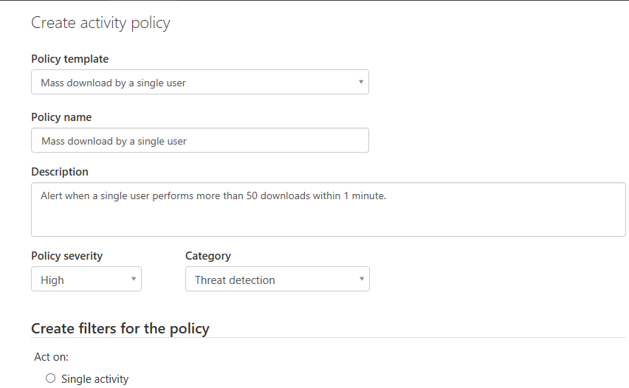 | Now you can see that the template has been applied, filling out most of the essential fields.  Let’s continue reviewing the remaining policy settings.  CLICK STEP(S)  Click scroll bar to scroll down.
Step 10 | 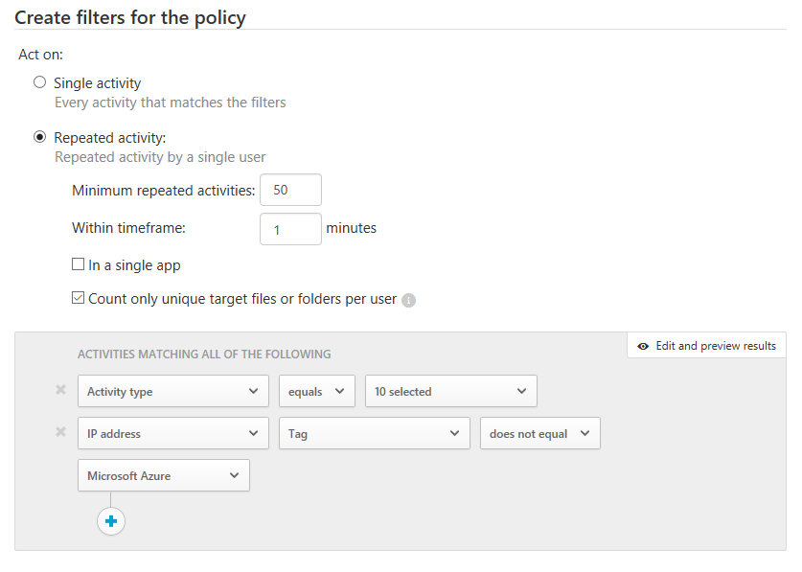 | Since you are now developing a policy to monitor a specific type of activity “Mass downloads by a single user”, versus a more general anomaly/incident detection policy; the parameters which you monitor would naturally be more targeted.  This is where the Create Filters for a Policy section comes into play, allowing you to select the specific conditions that will trigger an alert.  In this case:  - The number of repeated activities is set to 50  - The timeframe which this occurs (measured in minutes) is currently 1 minute  - Whether the activity comes from the same user or the same user/app.  Check out the different activities that are pre-selected and other options available under Activities matching all of the following
Step 11 |  | Moving on to Alerts.  CLICK STEP(S)  Click scroll bar to scroll down.  For this policy, let’s enable the email alerts and Suspend user options.  CLICK STEP(S)  Click Email alert checkbox.
Step 12 | 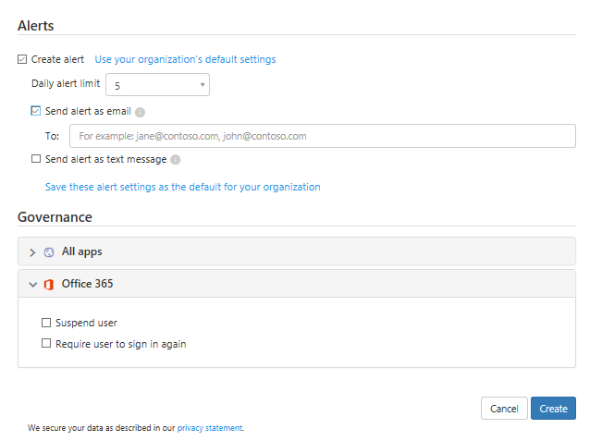 | CLICK STEP(S)  Click To: field.
Step 13 | 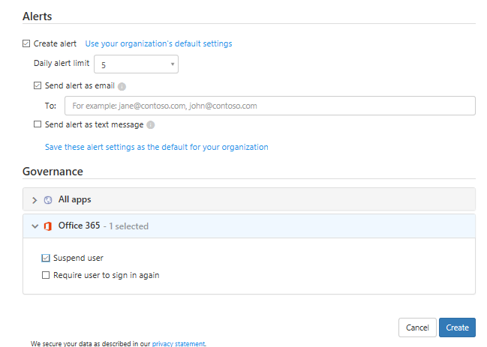 | Now that the Email alerts have been configured, let’s enable the Suspend user option by checking it’s checkbox.  CLICK STEP(S)  Under Governance: Office 365, click Suspend user checkbox.
Step 14 |  | Now the policy is ready for deployment. And we will have peace of mind that by the time we get this alert the user will have been automatically suspended.  CLICK STEP(S)  Click Create.
Step 15 | 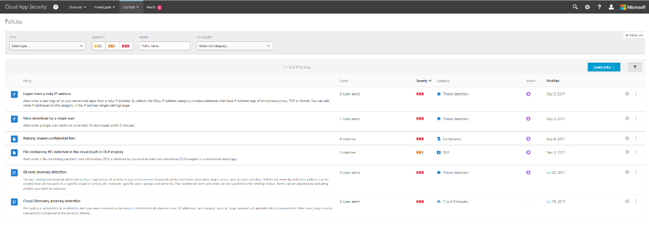 | With the email alerts and the suspend user features enabled, you now have peace of mind; knowing whenever a user violates this policy he/she will automatically be suspended by the time you receive the email notification.  As you can see Office 365 Advanced Security Management provides you with enhanced visibility and control into your Office 365 environment though:  - The ability to detect threats by helping you identify high-risk and abnormal usage, security incidents, and threats.  - Providing you with enhanced control by leveraging granular controls and security policies that can help you shape your Office 365 environment.  - Giving you enhanced visibility and context into your Office 365 usage and shadow IT though the discovery and insights that the solution provides, all without installing an end point agent.

