Create and Anomaly Detection Policy that will monitor and detect admin activity anomalies and send an alert / text message when a specified threshold is reached.
Step 1 | 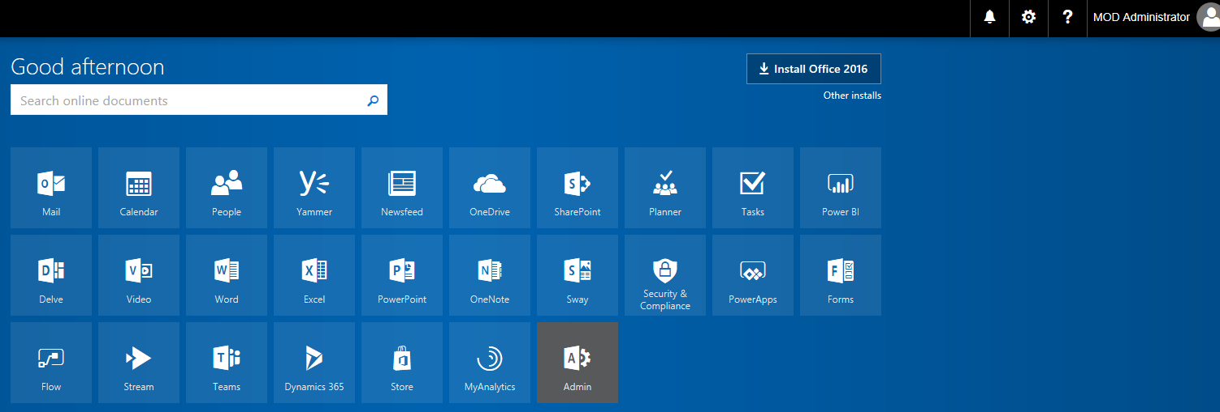 | Log into you tenant  https://login.microsoftonline.com/  and the click on the Admin Center 'App'
Step 2 | 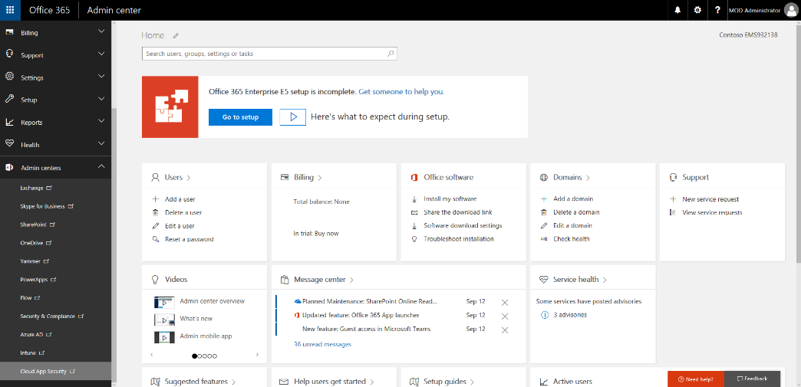 | In the left navigation, click on Admin Centers then click on Cloud App Security
Step 3 | 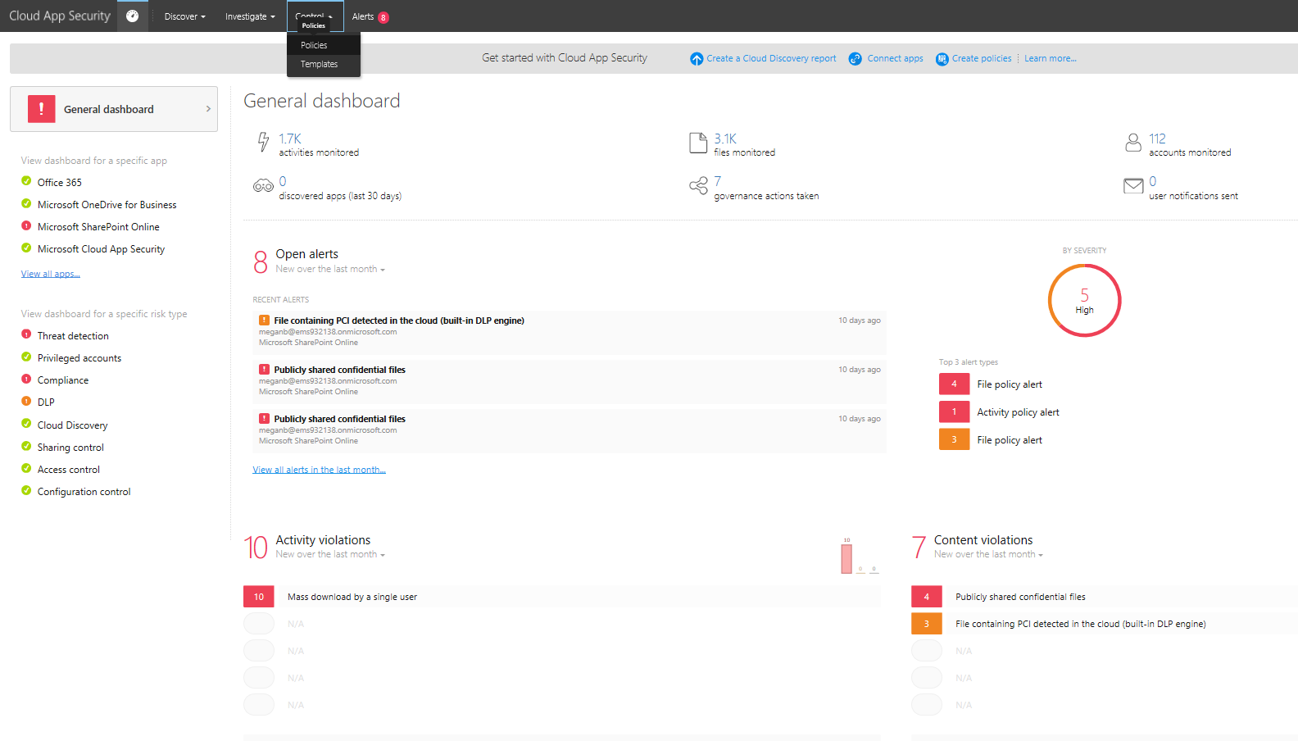 | From the Cloud App Security Home Page, From the Control menu, select Policies
Step 4 |  | CLICK STEP(S)  Click Create policy.
Step 5 |  | CLICK STEP(S)  Click Anomaly detection policy.
Step 6 |  | For this policy creation, let’s use the following values:  - Policy template: Let’s leave it as No Template  - Policy Name will be Admin Activity  - Description: Will be Monitoring Admin Activity for Anomalies  - Category: Will be left as Threat Detection.
Step 7 |  | - Activity filters: Will be changed from All monitored activity to Selected Activity  CLICK STEP(S)  Under Activity filters, click All monitored activity drop down menu.
Step 8 |  | CLICK STEP(S)  Click Selected activity.
Step 9 |  | CLICK STEP(S)  Click Select a filter… drop down menu.
Step 10 |  | CLICK STEP(S)  Click Administrative activity.
Step 11 |  | Now that the Activity filter has been set, let’s move on to the Risk Factor section.  This section contains a total of 8 subcategories:  - Logon Failures  - Admin Activity  - Inactive Accounts  - Location  CLICK STEP(S)  Click scroll bar to scroll down.
Step 12 |  | - Impossible Travel  - Device and User Agent  - Activity Rate  - Risky IP Address  All of the subcategories within the Risk factor section can be left to their default setting of on, as you see them now, turned off or applied to specific activities.  Now let’s move on to the Alerts section.  CLICK STEP(S)  Click scroll bar to scroll down.
Step 13 |  | Within the Alerts section, you have the ability to set the Alerting threshold and enable email/text alerting.  To get a better understanding of Alerting threshold, let’s uncheck the Alerting threshold checkbox to expand this section.  CLICK STEP(S)  Under Alerting threshold, uncheck the checkbox “Use default severity threshold settings (recommended)”.
Step 14 |  | Alerting threshold is a numeric value that will determine when alerts are generated.  The generation of alerts depends on what the Risk score bar below is set to.  The default score is 65, which means that any incidents with a Risk score of 65 or higher will generate an alert.  For this HOL, let’s set the Risk score to 85.  CLICK STEP(S)  Slide the Risk score bar to 85.
Step 15 |  | Now let’s move on to the Alerts configuration section.  Here, you have the ability to alter how many alerts you receive daily, enable email alerts and/or sending alerts via text message.  If you click on the Daily alert limit drop down menu, you can set your daily alert limit to any of the following values.  CLICK STEP(S)  Under Alerts configuration, click Daily alert limit drop down menu.
Step 16 |  | For today, let’s leave the daily alert limit as it’s default value of 5.  CLICK STEP(S)  Observe the options in the dropdown and select 5.
Step 17 |  | Now let’s configure the email and text alerts.  To enable email alerts, first check the checkbox.  CLICK STEP(S)  Click Email alert checkbox.
Step 18 |  | Then enter a valid corporate email address and hit Tab.  And yes, you are also able to enter multiple email addresses as well.  CLICK STEP(S)  Click To: field and enter a valid corporate email address.
Step 19 |  | Email alerts have been configured, let’s move on to configure the text message alerts  CLICK STEP(S)  Click Send alert as text message checkbox.
Step 20 |  | As you can see, the phone number field provides you a template to follow.  If you do not use the correct phone number format, you may receive an error message when you attempt to create the policy.  CLICK STEP(S)  Click the phone number field and enter a phone number in the specified format.
Step 21 |  | Now that the policy configuration is complete, it’s time to deploy it.  CLICK STEP(S)  Click Create.

