Preventing anonymous document sharing

In this quick section, we want to implement a company policy to prevent anonymous document sharing. This will require invited guests to log in with their email address.

1) Log into you tenant
https://login.microsoftonline.com/

2) Click on the Admin Center 'App' Note: if you are already logged in you can also find the app from the App launcher menu in the top left corner (aka "the waffle").

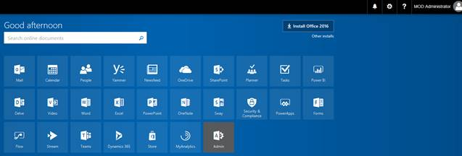

3) In the left navigation, expand Settings and click Security & privacy.

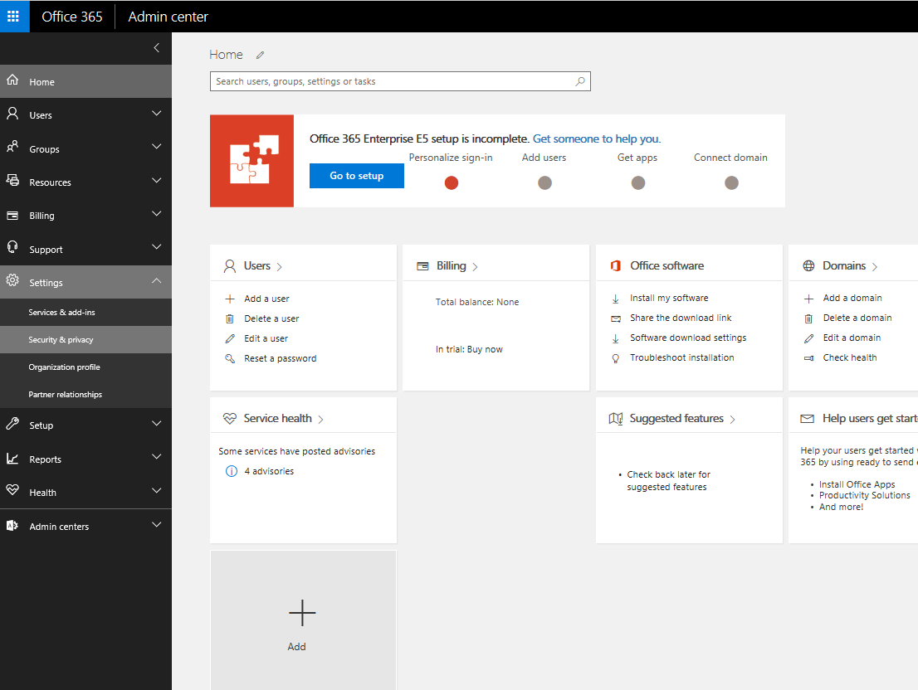

4) On the security and privacy page, find Sharing and click Edit.

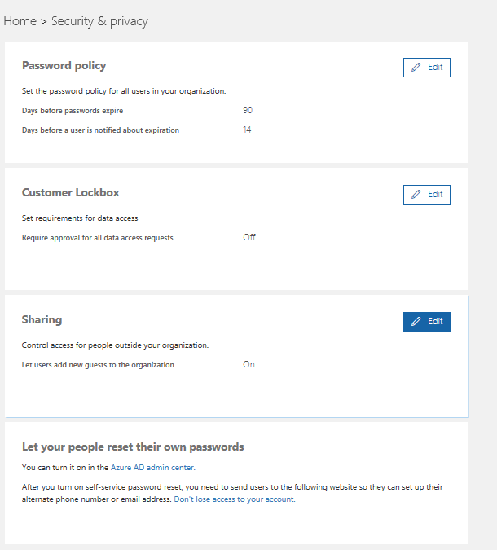

5) On the sharing screen, Let users add new guests to the organization is a prerequisite for sharing documents externally. Click the Site Setting button which conveniently will launch the settings for external sharing.

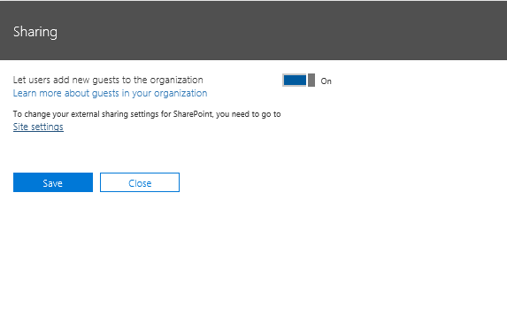
6) If you wanted to lock down any external sharing, you would toggle the External sharing switch to off. In our case, we want to choose New and existing external users (sign-in-required) to prevent sharing business documents anonymously.

