Cloud Discovery

In this lab, we will create and view a Cloud Discovery Dashboard where you can:
- Analyze which cloud apps are being used in your organization
- Understand Office 365 use and adoption trends
- Compare data to other cloud apps that are being used in your organization

1) Log into you tenant
https://login.microsoftonline.com/

2) Click on the Admin Center 'App'

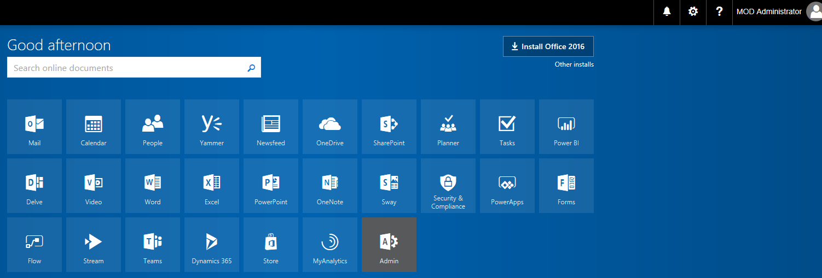

3) In the left navigation, click on Admin Centers then click on Cloud App Security

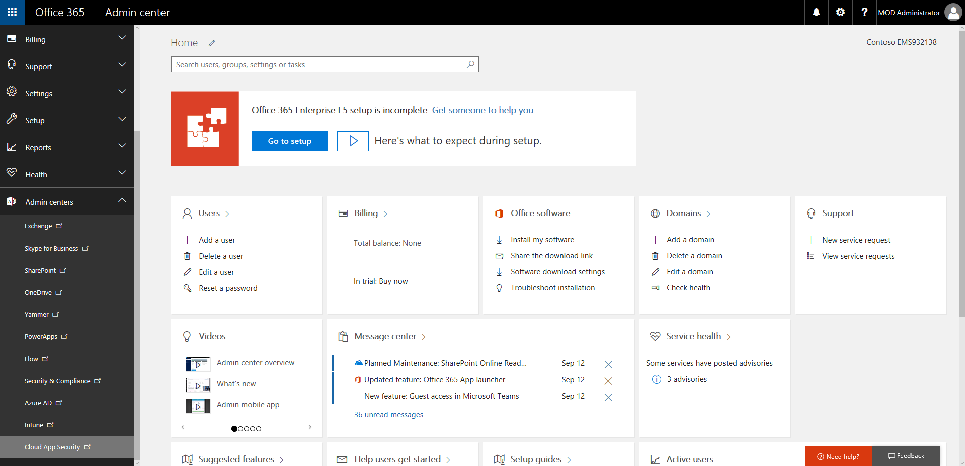

4) From the Cloud App Security Home Page, From the Discover menu, select Create a snapshot report

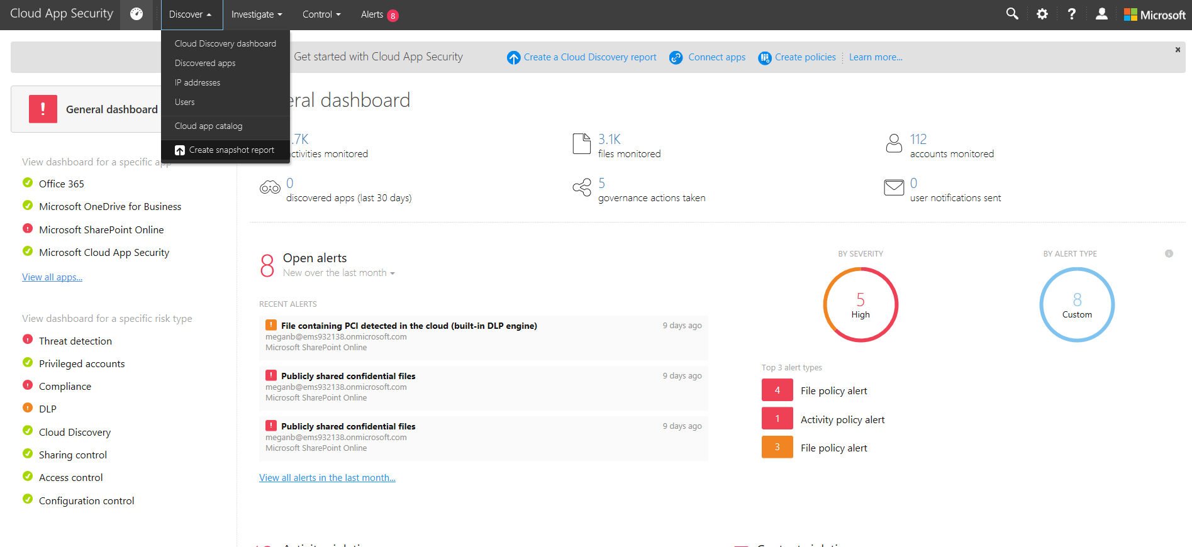

5) Complete the Name and Description and choose Cisco IronPort WSA as the data source then click "view and verify" so that we can get a sample log file to test from the web security appliance / firewall / gateway. Notice all the different data sources that you could use.

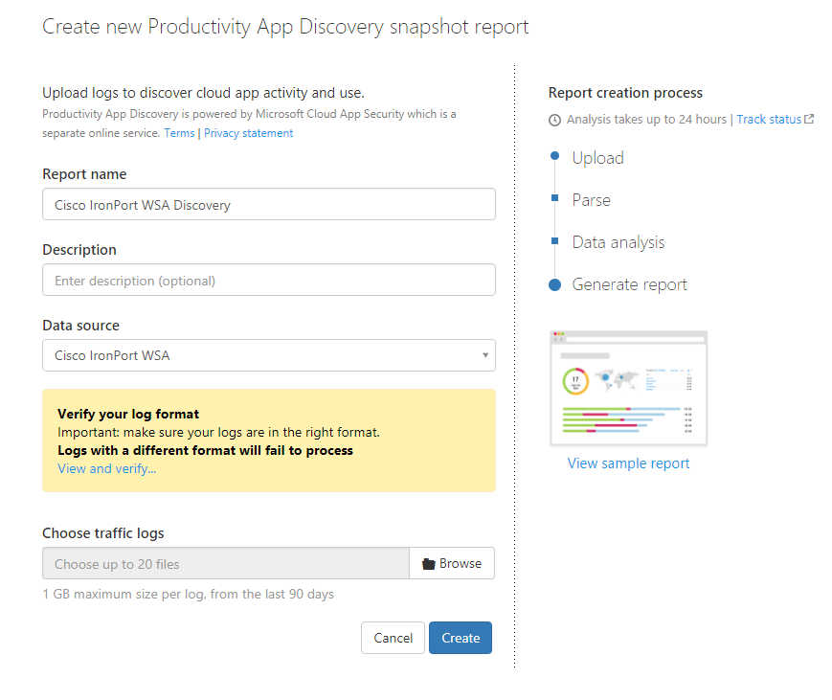

6) Click Download sample log and save it locally to your device. Close the dialog when done.

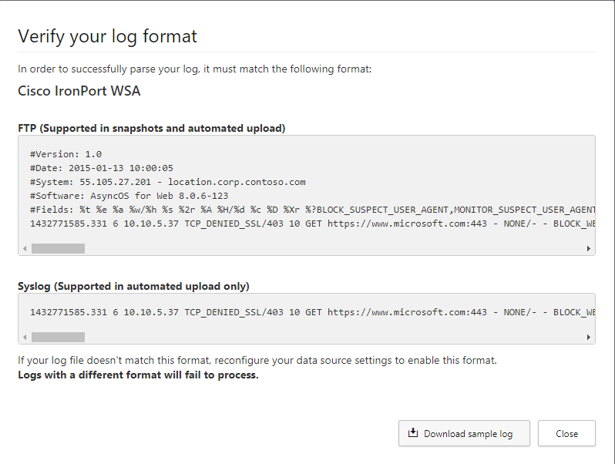

7) That will return you to the Create new Cloud Discovery snapshot report page where you can click Browse under Choose traffic logs and upload the sample file you just downloaded. Then click Create

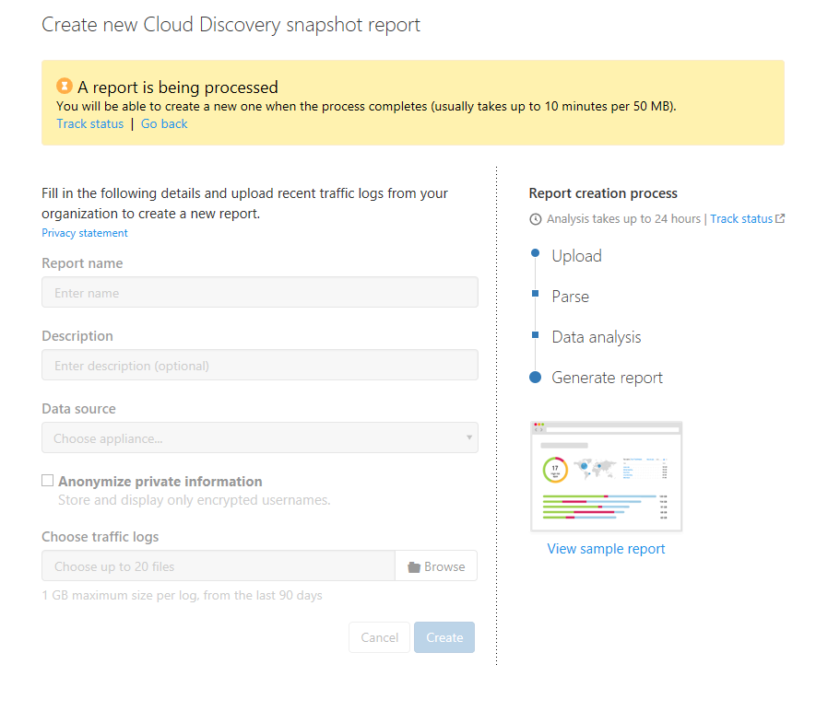
8) You should now be in the Manage Snapshot Reports screen where your snapshot should have a "Processing" status. You can return to this in about 15 minutes when it is done but note it could take up to 24 hours to process the logs.

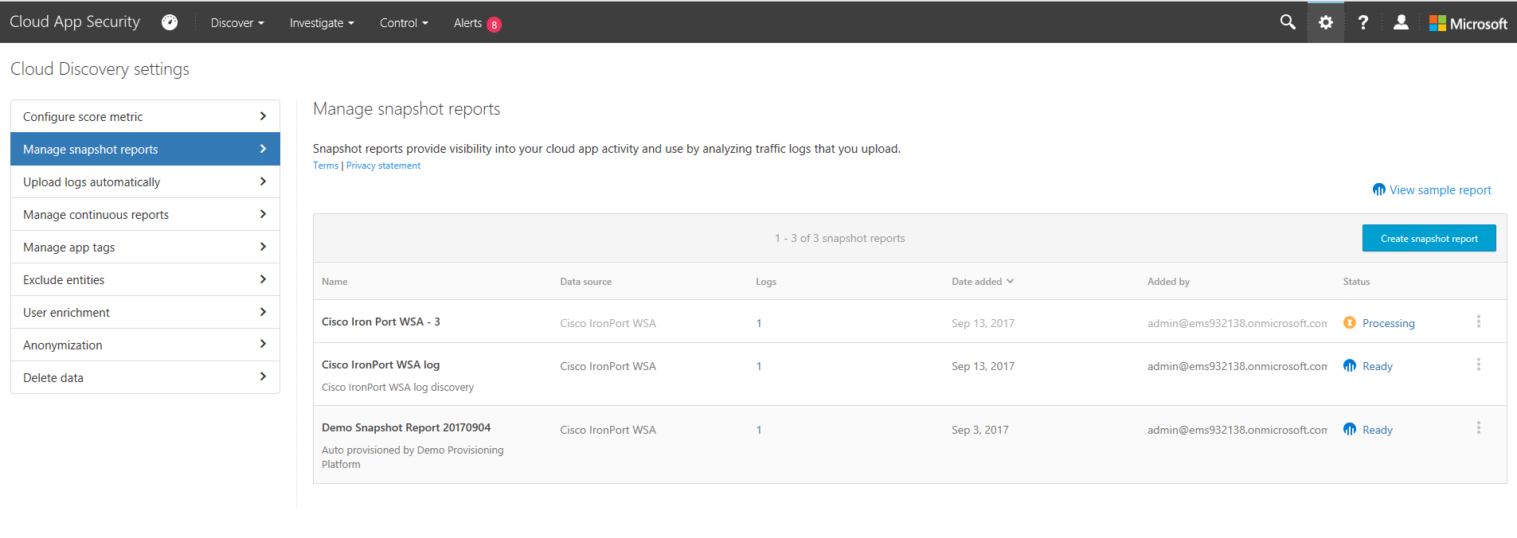

9) In the meantime - check out the Demo Snapshot Report 20170904 (list shown above) that should be included with a "Ready" status in your demo tenant. Click on that report to view.

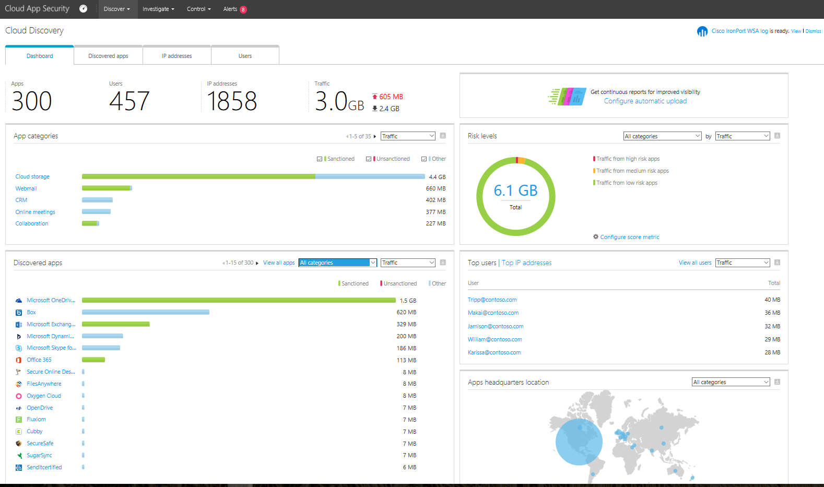

10) Spend some time exploring the different filtering options and tabs. For example, in the Discovered apps, try selecting the Productivity or Cloud Storage apps and seeing how many users are using unsanctioned apps.

